|  |  |  |  |  |  |
| --- | --- | --- | --- | --- | --- |
| Date | 28-Nov-22 | | | Tester Name | Shahabuddin Syed |
| Environment | Penfax - Test | | | Login used |  |
| Operating System | Windows | Version: | Update: | | |
| Software Used | Edge | Version: | Update: | | |
| Select Software | Version: | Update: | | |
| Release version | 22.4.1 | | | | |
| Title | SRB | | | | |
| Test Type | Regression | | | | |
| Test Scenario | Process a spousal breakdown payment to remain in PEPP who is currently a member | | | | |
|  |  | | | | |
| Expected Results |  | | | | |
| Pass/Fail | Pass | | | JIRA# | JIRA- 5160 |

Describe your steps with screenshots:

Search form the stakeholder

Enter StakeholderID – “238263”

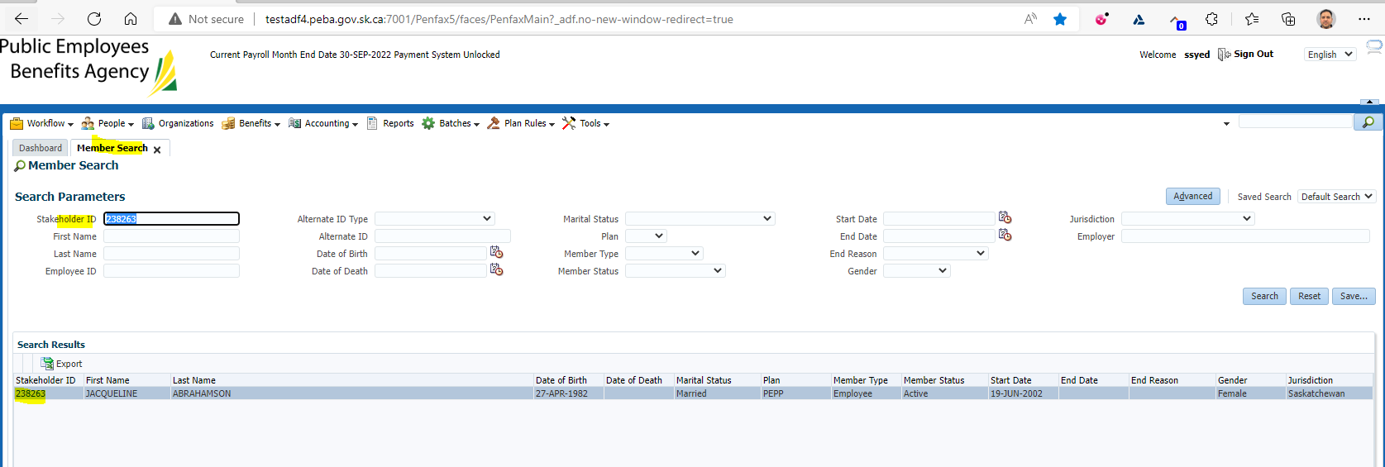

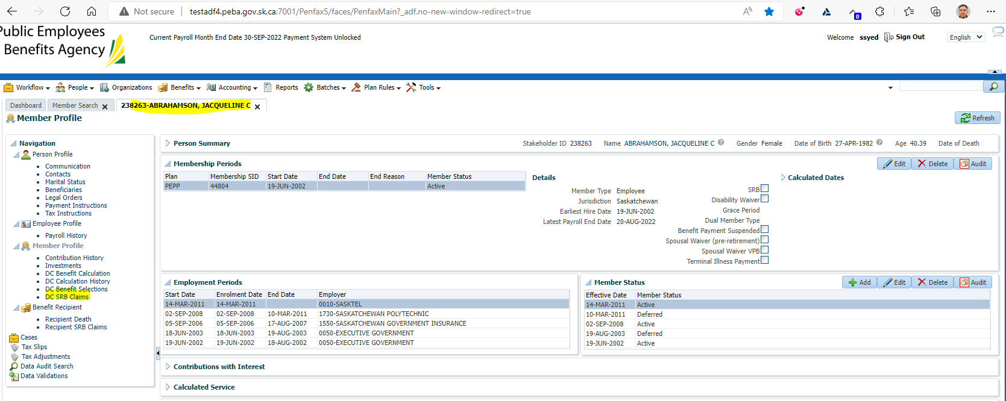

Click Add

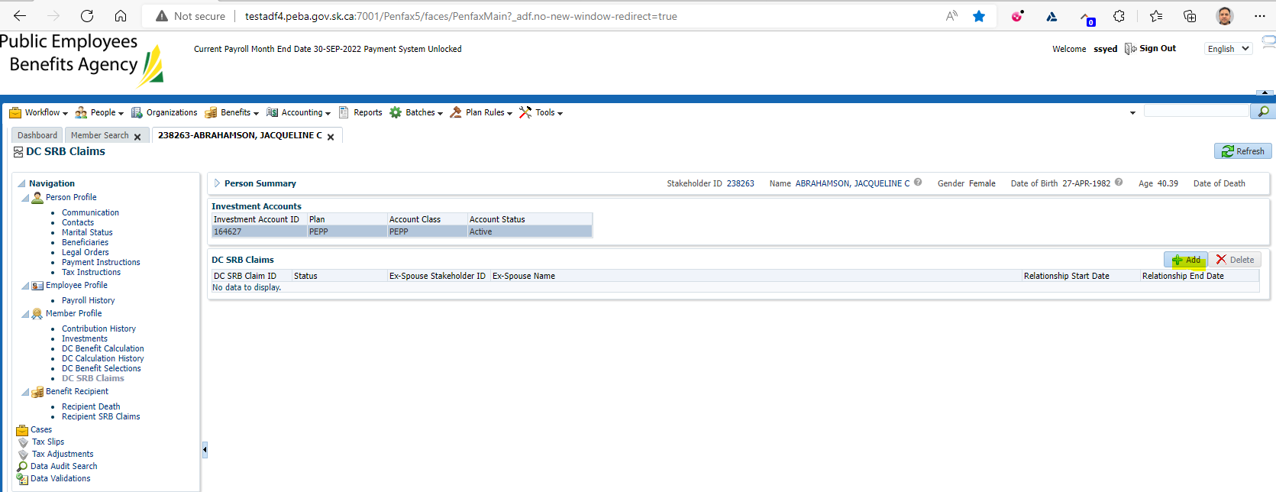

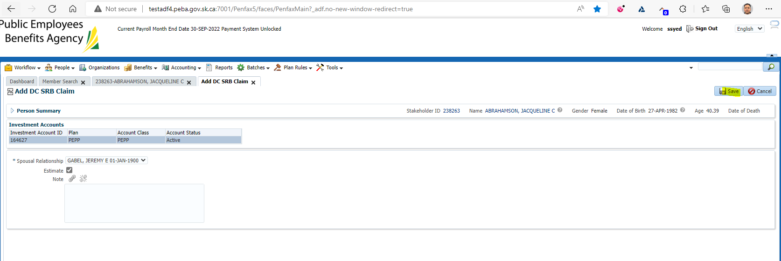

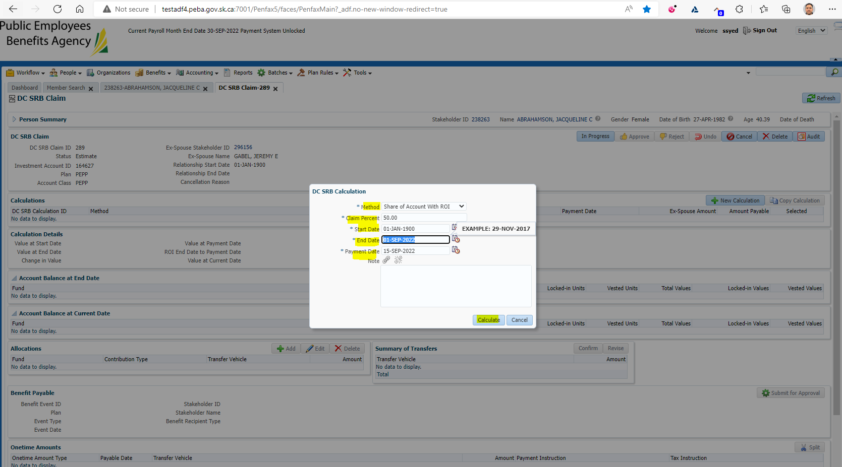

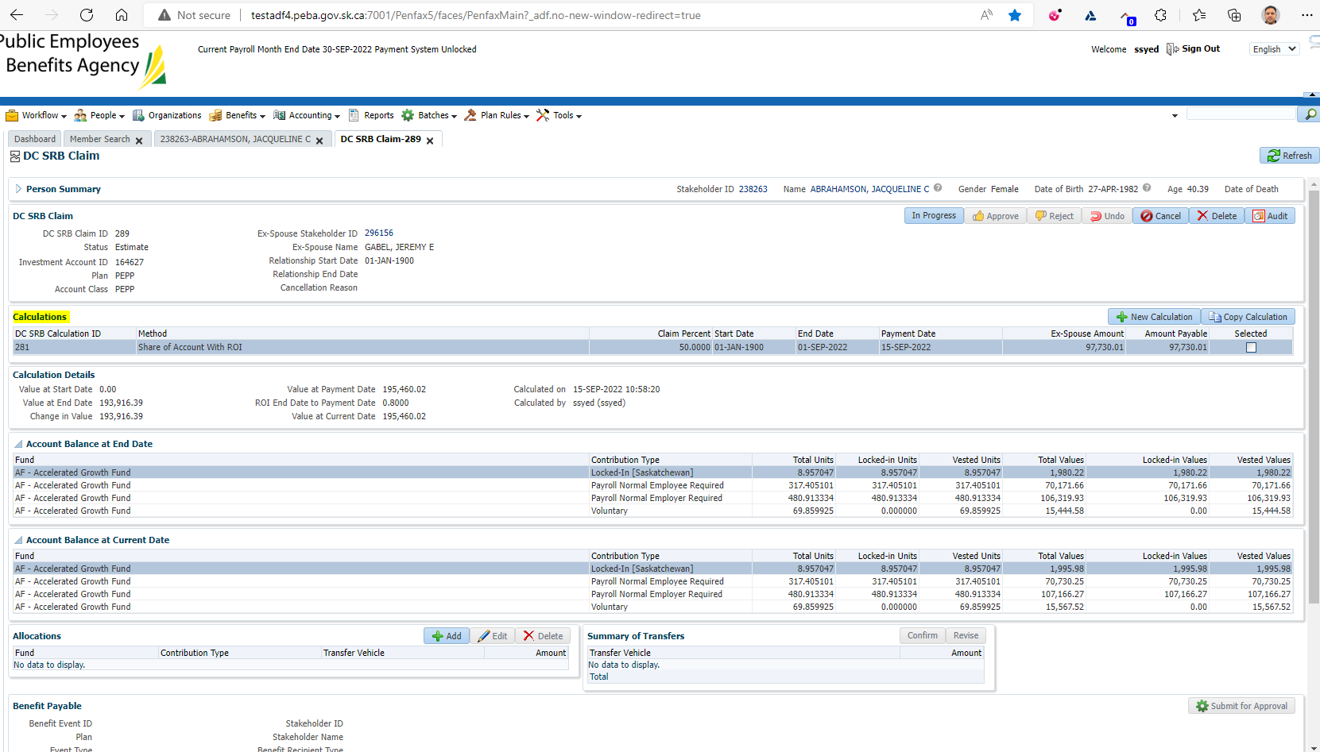

Click Add under Allocations

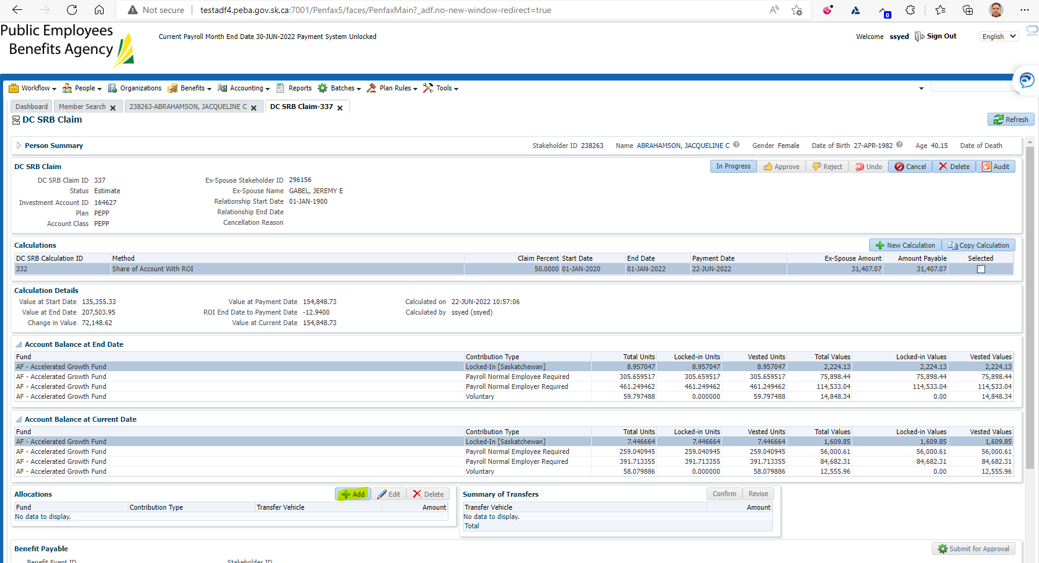

Under Allocations Click Add  
Under Transfer vehicle select PEPP  
Under amount input the Ex-Spouse Amount  
Click Save  
Under Summary of Allocations click Confirm

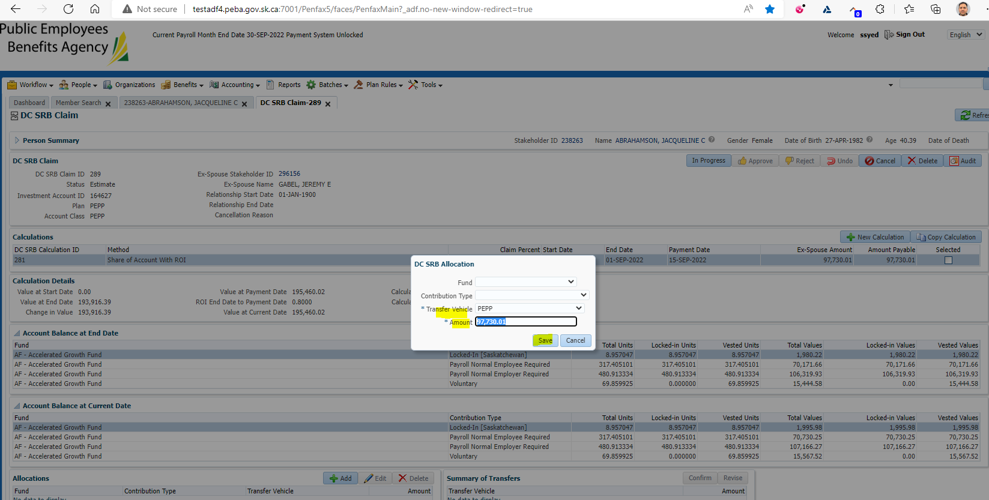

Click Confirm button

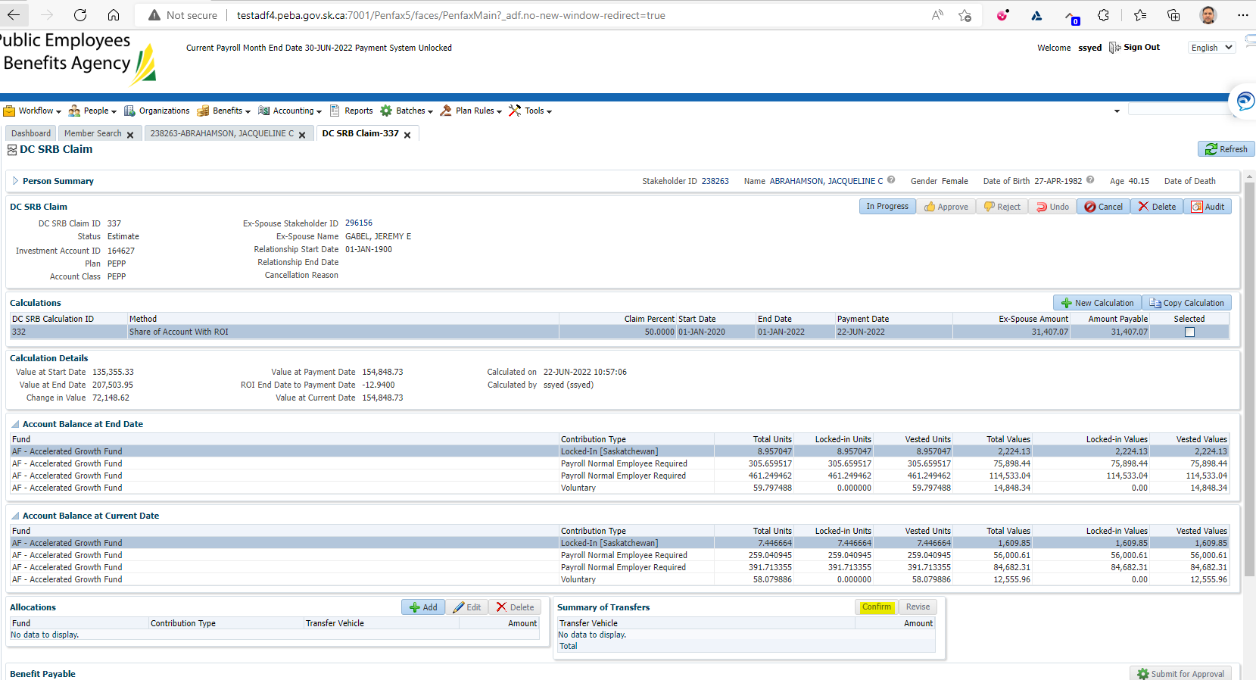

At the top of the screen under DC SRB Claim put In Progress  
Click Submit for Approval  
Approve the file

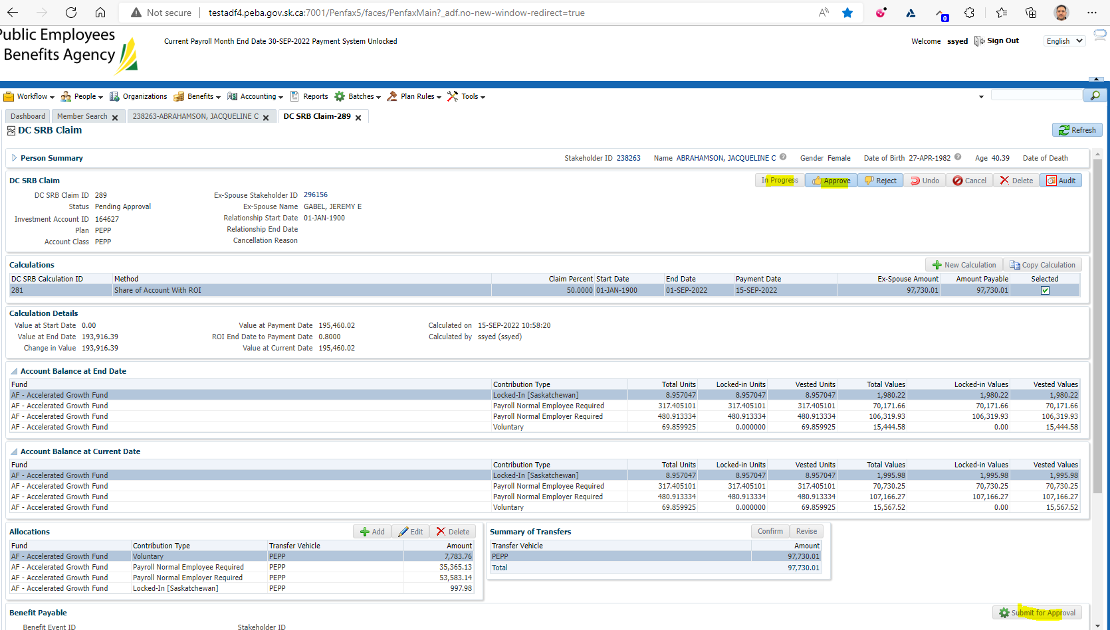

Wait for the overnight batches to run

Verify the payment has been paid and that payment has been deposited into the ex-spouse's own PEPP account

**Note: Letter will not be generated if the money is transferred to an inside transfer vehicle, like a PEPP or VPB

**Note: Letter will be generated only if the money is transferred to an outside transfer vehicle, like a LIRA or RRSP

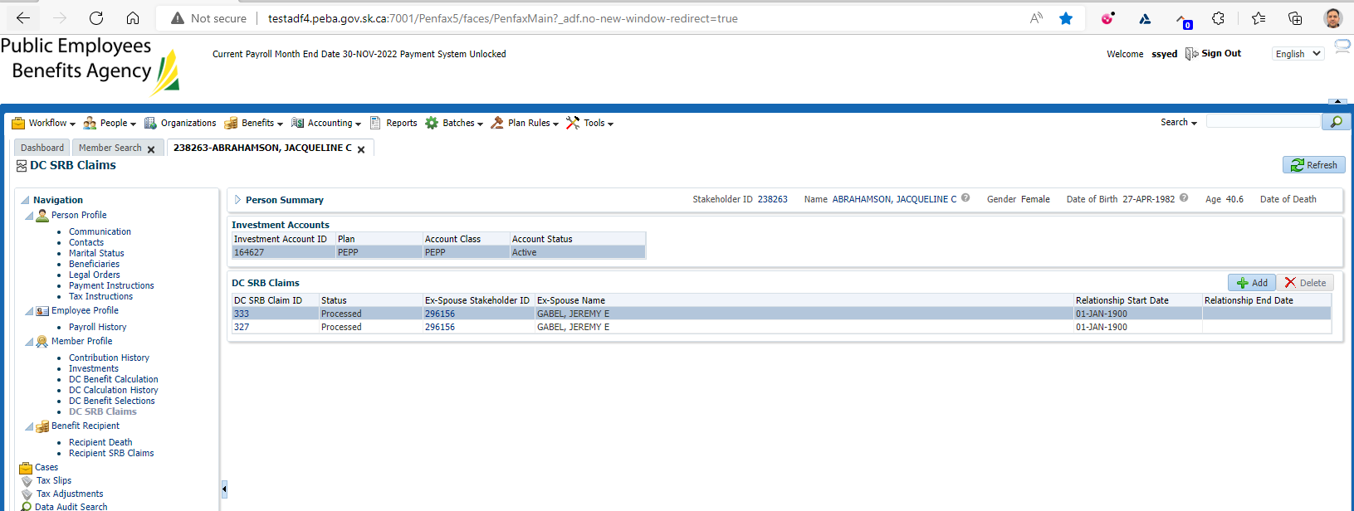

SID: 313146

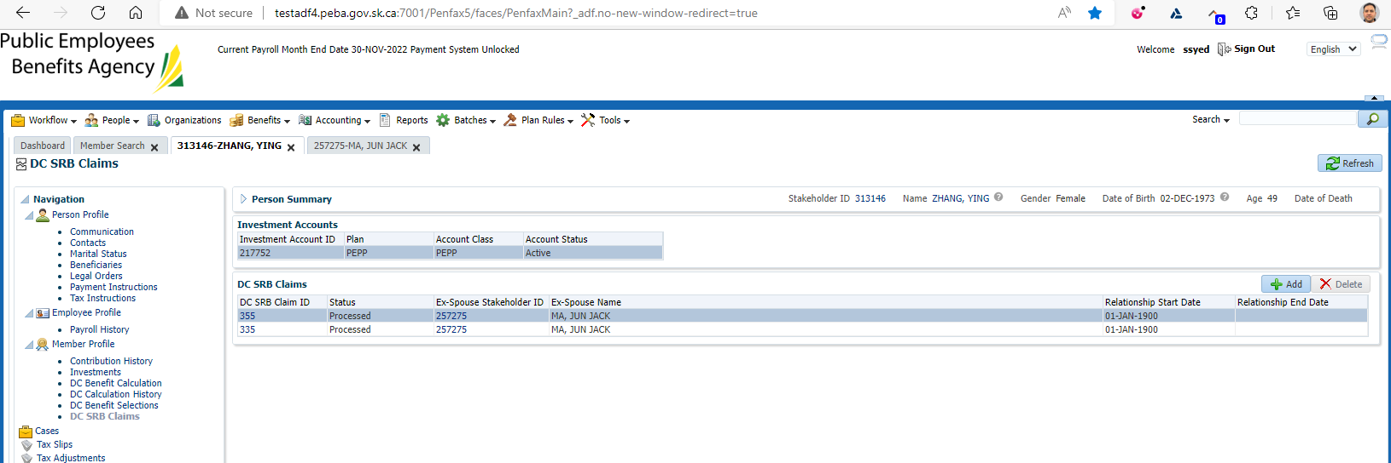

Result: Pass

Letters will not get generated for inside transfer vehicle such as PEPP or VPB